6.Systems in our body

Body Organisation:
- Cells are the basic units of structure and function in the human body. These are present in all living beings. Each cell carries out essential life processes that help the body to survive.
- A group of connected cells that perform a similar function makes a tissue. Four different kinds of tissues found in the human body are muscle, epithelial, nervous, and connective tissues.
- An organ is a structure that has two or more types of tissues operating together to carry out the same function. Example: Heart, lungs, kidneys, etc.
- An organ system consists of a group of organs that work together to carry out different bodily functions.
The different organ systems of our body are briefly described below—

1. What is Nervous System:
- The nervous system constitutes the brain, spinal cord, and nerves.
- It controls and coordinates sensations, thoughts, movements, and other activities of the body.
- The flow of signals from the brain and stimulus from the tissues follow the given path—
  - Signal: Brain → Spinal cord → Nerves → Organ/Tissue
  - Stimulus: Organ/Tissue → Nerves → Spinal cord → Brain
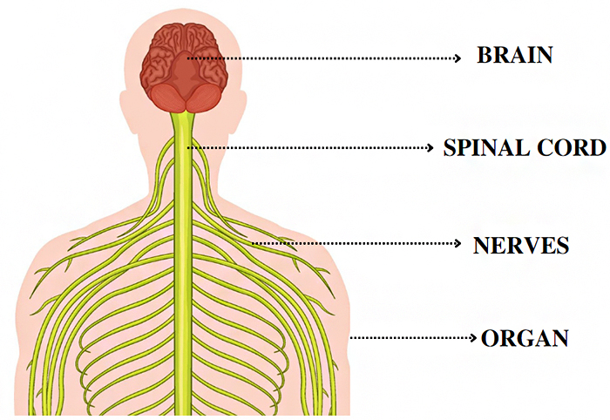

2.What is Respiratory System?
- The respiratory system helps to breathe in and breathe out, transporting oxygen to the body cell, and removing waste gases from the body, including carbon dioxide.
- The main organs of the respiratory system are the nose cavity, voice box, windpipe, and lungs.
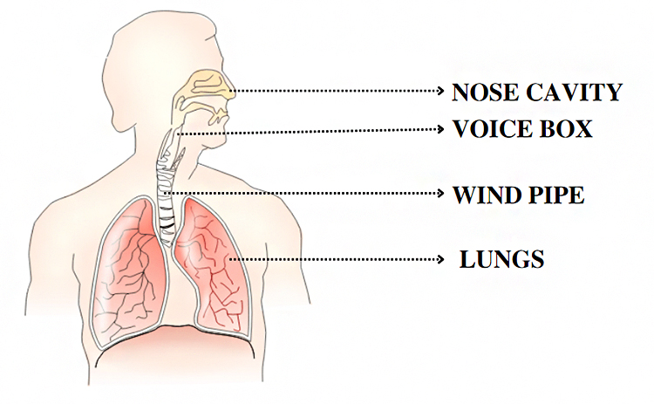
- The airflow between the nasal cavity and the lungs follows the path—
  - Breathing in: Nose cavity → Voice box → Wind pipe → Lungs
  - Breathing out: Lungs → Wind pipe → Voice box → Nose cavity

3.What is Circulatory System:
- The circulatory system carries oxygen, nutrients, and other essential substances to the different parts of the body via the blood.
- It is also responsible for collecting waste materials from the cells and tissues to be expelled from the body.
- The heart, arteries, veins, and capillaries form the components of the circulatory system.
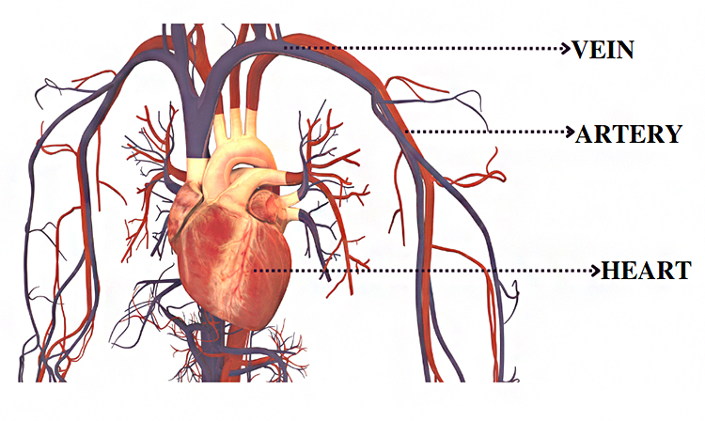
- The heart pumps out oxygen-rich blood that travels through the arteries and veins following this path—
- The blood flow in the body is-
  - Oxygen-rich blood: Heart → Artery → Organ
  - Oxygen-poor blood: Organ → Vein → Heart

4.What is Skeletal System?
- The skeletal system gives the framework to support the body and protect the internal organs.
- It consists of bones, ligaments, and cartilage.
- This system helps in movements and protects organs like the heart and lungs from external harm.
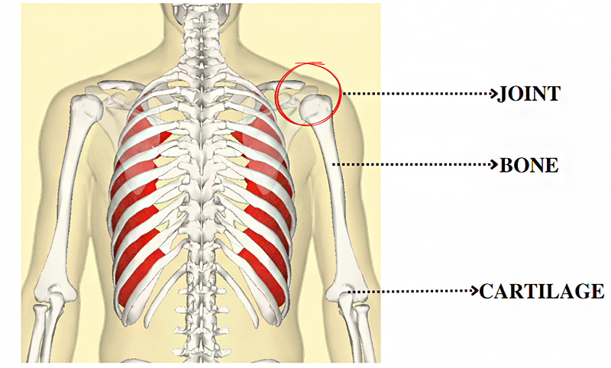

5.What is Muscular System?
- Muscles control all movements in our bodies.
- Some muscles work without us thinking, like the beating of the heart.
- Other muscles are controlled by our thoughts and allow us to do our work and move around.
- All the muscles in our body constitute the muscular system.
- The muscular system consists of muscles and tendons. Three types of muscles are present in our body—skeletal muscles, cardiac muscles, and smooth muscles.
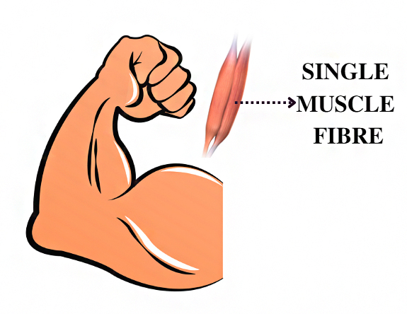

6.What is Digestive system?
- The digestive system helps digest foods and absorbs nutrients, minerals, vitamins, and water that provide energy to the body.
- The important organs that make up the digestive system are the liver, pancreas, stomach, small intestine, and large intestine.
- After the food is chewed in the oral cavity, it passes to the stomach via the oesophagus.
- Their absorption of nutrients takes place in the small intestine.
- Undigested food material passes through the large intestine and is discharged from the body through the anus.
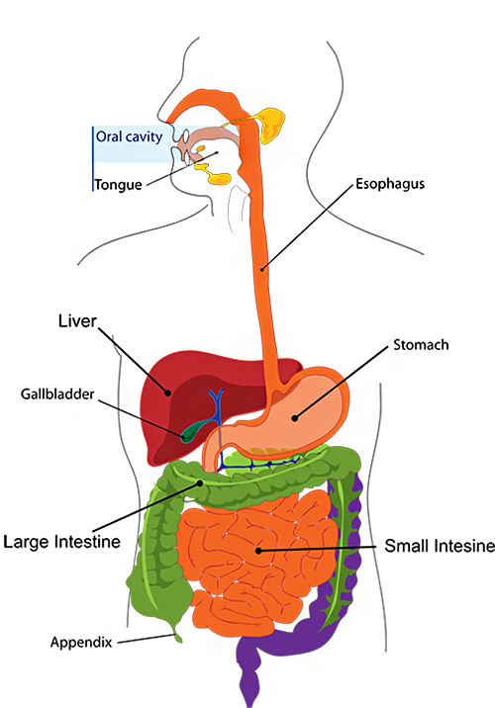

7. What is Excretory System?
- The system that helps in the removal of waste materials from the body is called the excretory system.
- These waste materials are thrown out of the body through urine.
- It consists of pair of kidneys, ureter, urinary bladder and urethra.
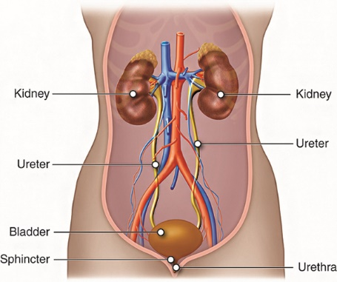
- The flow of the urine follows the path— Kidney → Ureter → Bladder → Urethra

